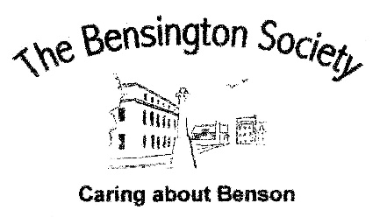

THE BENSINGTON SOCIETY – MAY 2021

March was an eventful month, with our 24th Covid-19 Entertainment Communication being sent out. But I don’t just want to talk about Covid-19 or even Spring – but we might as well start there.
At last signs of the Pandemic are diminishing with UK cases as low as 79 per 1m people (The Times), the lowest in Europe save Portugal. That fact alone might not mean that foreign holidays are just around the corner but it should at least encourage us to believe that ‘normal’ life might not be too far away.
Another other Covid-19 fact is that, following nomination by the Society, the Benson Help Hub has been awarded a much deserved and coveted High Sheriff Award. This fact might well be recorded elsewhere in this Bulletin but, no matter, it should be mentioned time and time again as it is so well deserved. Kindness might not yet be endemic but in Benson there seems to be a ‘Pandemic’ of it.
Moving on to Spring and the third of our ZOOM talks – ‘William III, the making of the modern world.’ With hardly a mention of ‘King Billy’ and Ireland, Professor Tony Claydon suggested William himself was crucial to the rapid modernisation of Britain that occurred in the 1690s. His ambitions, political style, skills, and experience shaped and enabled a series of far-reaching changes. William oversaw an exponential expansion of the state; a stabilisation of political conflict into a two party system that helped to contain tensions; and a new role for parliament which ended the endless round of constitutional crises that had marked British history for a hundred years. Tony showed just how a leader’s individual personality can be important in the development of societies. The measure of how well the talk was received was that it ran well over time due to the number of interesting questions that were asked.
The April Zoom talk on the 30th is entitled ‘Pleasure Boating on the Thames’. The late Victorian period saw the river transformed into a vast conduit of leisure - steam launch trips, Venetian fairs, regattas, picnics, carnivals and ‘three men in a boat’. This talk, by Simon Wenham, covers more than 150 years of pleasure boating.
On the 28th May, Mark Lewis will tell us about the ‘Sentinels of the Sea’ – the amazing history of Lighthouses from the Pharos of Alexandria till today, with an insight into the lives of the keepers,
including some of the extraordinary heroic stories associated with them.

Coming right up to date, planning issues have surfaced with regards to the planned extension to the Parish Hall and the communication – or rather lack of it – to the residents. Your Committee has been very much involved in challenging the Parish Council’s lack of due process, even in the following of its own rules of oversight, in the likely spend of over £700,000 on the extension. The only information that was in the public domain regarding the latest proposals only appeared on the Council’s website a couple of days before the Extraordinary Public Meeting, called for by the necessary 6 residents. It should be made clear that the Society fully understands and supports the objectives of an extension. Our objections are about a lack of public consultation, cost benefit analyses and a business case.
The Society’s Chairman has written to the Council asking their Chairman to write an open letter to be published in the Bulletin explaining why and how the lack of proper oversight occurred. It will be interesting to see if it ever appears. Parish Council elections are to be held in 2023.
According to the late Rabbi Jonathan Sacks – “Optimism is the belief that things will get better. Hope is the belief that, together, we can make things better” – so, let’s all be hopeful.
David McGill

