THE BENSINGTON SOCIETY
March Talk - Visitors Welcome
7 for 7.30 pm, Friday 27th March, Benson Parish Hall
Non-Members Entrance Fee £4
Supper £5 - Bar Available

"WILLIAM III” - THE MAKING OF THE MODERN WORLD”
William III as a crucial factor in Britain's emergence as a world power
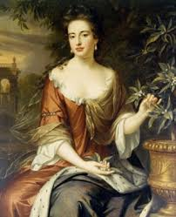
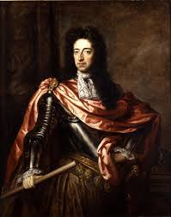
One can make a strong case that the period 1688-97 witnessed the birth of modern Britain. The revolution of 1688-9 ended divine right monarchy; the revolution also allowed a high degree of religious toleration; and in the war with France that ran from 1689-97, modern public credit, a large and professional civil service, and powerful and effective armed forces, were developed. This all enhanced the power of parliament, establishing it as a standing institution in government, and perhaps the most powerful part of the constitution. This talk will outline these changes but will argue they were brought about by the political priorities and skills of William III to an extent that is rarely recognised.

SPEAKER
Professor Tony Claydon

Tony Claydon is Professor of Early Modern History at the University of Bangor. He specialises in the political, religious, religious and print culture of late Stuart England, and has written books on propaganda after the Glorious Revolution; Protestantism and national identity; William III’s political priorities and style; the idea of Christendom in the late Stuart age; and – most recently – conceptions of time, chronology, and history in the decades after 1688/

